Chapter 1 Introduction to FLUX AI and Image Generation 4

Overview 4

What is FLUX AI? 4

What is ComfyUI? 4

Overview of AI in Image Generation 4

Introduction to FLUX AI 4

The Role of ComfyUI 4

Chapter 2 Getting Started with FLUX AI 5

With ComfyUI 5

Pre-requisites: 5

Steps to configure FluxAI with ComfyUI 6

With Python Notebook 10

Step 1: Setting up a Python Environment 10

Step 2: Activate python environment 11

Installation and Setup 11

System Requirements 11

Chapter 3 Understanding ComfyUI Interface 12

Section 1: Quick Start for Image Creators 15

User Interface Walkthrough 15

Key Features 15

Section 2: In-Depth Guide for Tech Enthusiasts 15

User Interface Walkthrough 15

Key Features and Functionality 15

Chapter 4 Basics of Image Generation with FLUX AI 16

Section 1: Quick Start for Image Creators 16

Simple Image Generation 16

Section 2: In-Depth Guide for Tech Enthusiasts 16

How FLUX AI Uses Generative Models 16

Simple Image Generation Techniques 16

Chapter 5 Advanced Image Generation Techniques 23

Section 1: Quick Start for Image Creators 23

Experimenting with Prompts 23

Section 2: In-Depth Guide for Tech Enthusiasts 23

Detailed Prompts and Instructions 23

Fine-Tuning Model Outputs 23

Chapter 6 Customizing Images in ComfyUI 24

Section 1: Quick Start for Image Creators 24

Applying Effects and Styles 24

Section 2: In-Depth Guide for Tech Enthusiasts 24

Layering and Advanced Customization 24

Chapter 7 Optimizing AI-Generated Images 25

Section 1: Quick Start for Image Creators 25

Improving Image Quality 25

Section 2: In-Depth Guide for Tech Enthusiasts 25

Removing Artifacts and Refining Outputs 25

Chapter 8 Use Cases for FLUX AI Image Generation 26

Section 1: Quick Start for Image Creators 26

Real-Life Applications 26

Section 2: In-Depth Guide for Tech Enthusiasts 26

Professional Applications and Use Cases 26

Contents

**NOT THE REAL TABLE OF CONTENTS!!**

Table of Contents

1. **Introduction to FLUX AI and Image Generation**
   * Overview of AI in image generation
   * Introduction to FLUX AI
   * What is ComfyUI?
2. **Getting Started with FLUX AI**
   * Installation and setup
   * System requirements
   * Installing necessary libraries and dependencies
3. **Understanding ComfyUI Interface**
   * User interface walkthrough
   * Key features and functionality
   * Customizing your workspace
4. **Basics of Image Generation with FLUX AI**
   * Introduction to generative AI models
   * How FLUX AI uses generative models
   * Simple image generation techniques
5. **Integrating FLUX AI with ComfyUI**
   * Setting up FLUX AI in ComfyUI
   * Importing models and image templates
   * First image creation walkthrough
6. **Advanced Image Generation Techniques**
   * Working with prompts and detailed instructions
   * Fine-tuning model outputs
   * Adjusting parameters for unique results
7. **Customizing Images in ComfyUI**
   * Applying styles and effects
   * Combining multiple images
   * Layering and enhancing visual output
8. **Optimizing AI-Generated Images**
   * Improving resolution and quality
   * Removing artifacts and refining outputs
   * Batch processing images
9. **Use Cases for FLUX AI Image Generation**
   * Visual storytelling with AI
   * Marketing and advertising applications
   * Creating art and designs
10. **Best Practices and Tips**
    * Maximizing FLUX AI's potential
    * Troubleshooting common issues
    * Ethical considerations in AI-generated content
11. **Conclusion**
    * Future of AI in creative industries
    * Where to go from here: Exploring other AI tools

# Chapter 1 Introduction to FLUX AI and Image Generation

## Overview

### What is FLUX AI?

FLUX AI is a tool that lets you create stunning images by simply typing a description of what you want to see. It uses advanced artificial intelligence to understand your description and generate an image based on it.

### What is ComfyUI?

ComfyUI is a simple interface that helps you interact with FLUX AI without needing to write any code. You can just type in your prompt, and it will handle the rest.

## Overview of AI in Image Generation

AI-driven image generation uses machine learning models, particularly deep learning architectures like Generative Adversarial Networks (GANs) or Variational Autoencoders (VAEs), to synthesize images based on learned patterns from large datasets.

### Introduction to FLUX AI

FLUX AI leverages deep learning algorithms to understand prompts (input text) and generate corresponding visuals. It is trained on a wide range of image datasets and has the ability to transform textual input into creative, accurate, and sometimes abstract representations.

### The Role of ComfyUI

ComfyUI serves as a bridge between the user and the complex models running in the background, providing a simple, graphical interface to work with FLUX AI. It hides the complexity of coding and computation, making AI-based image generation accessible to users of all skill levels.

# Chapter 2 Getting Started with FLUX AI

## With ComfyUI

### Pre-requisites

**Installation and Setup**

Setting up FLUX AI and ComfyUI involves downloading necessary packages, configuring the environment, and installing the required libraries:

* Download FLUX AI from the official site.
* Install Python 3.8+ along with libraries like TensorFlow or PyTorch.
* Install ComfyUI and configure it for GPU-based acceleration if available.

**System Requirements**

For optimal performance, you should have:

* CPU: Intel i5 or AMD Ryzen, higher or equivalent with 4 or more cores.
* GPU: NVIDIA GTX 1660 or higher with 6GB of VRAM for faster rendering.
* RAM: 16GB or higher.

## Steps to configure FluxAI with ComfyUI

**Step 1: Checking System Requirements (Refer image below)**

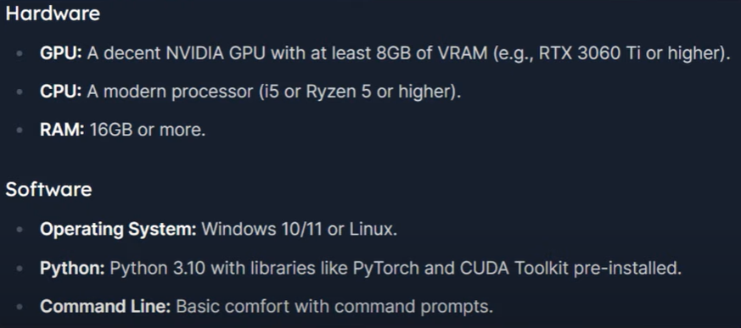Figure 1. Minimum System Requirements

*How to check system requirements?*

*If you are not sure about the VRAM please follow the steps below:*

1. *Click on windows key and search for “RUN” system application*
2. *Type “dxdiag” in the dialogue box and click on OK*

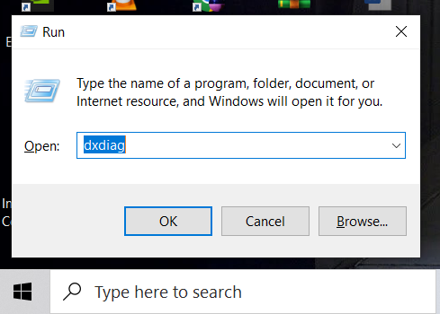

1. *Select the appropriate Display and check for the Display Memory*

*(refer below image)*

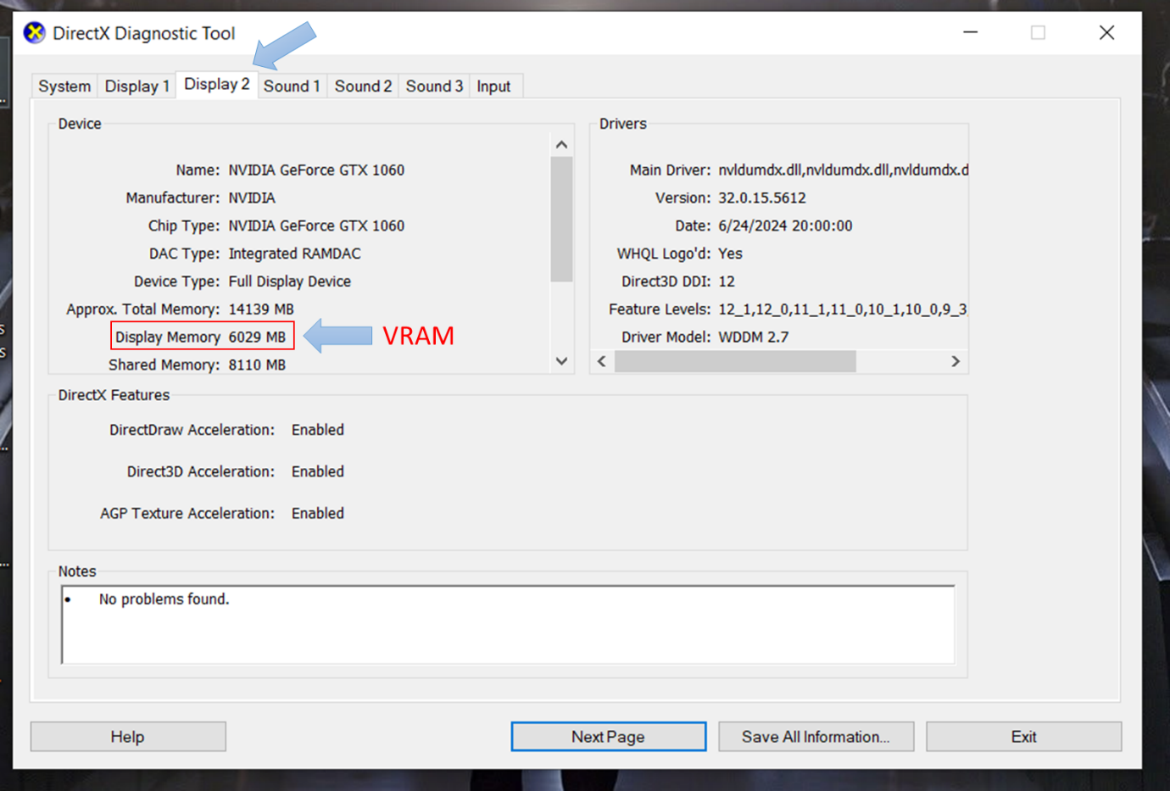

**Step 2: Click on link below to download ComfyUI**

Link: [Download Comfy UI](https://github.com/comfyanonymous/ComfyUI/releases/latest/download/ComfyUI_windows_portable_nvidia.7z)

**Step 3: Extract the files downloaded**



**Step 4: Download FluxAI from HuggingFace**

Now we will start placing essential items like VAEs, clips, encoders within the folders of ComfyUI.

**Models:**

* Download dev version of fluxAI: <https://huggingface.co/black-forest-labs/FLUX.1-dev/blob/main/flux1-dev.safetensors>
* Download schnell version from here: <https://huggingface.co/black-forest-labs/FLUX.1-schnell/blob/main/flux1-schnell.safetensors>
* Place these 2 downloads within “ComfyUI\models\unet”

**Encoders:**

* Download all 3 encoders from <https://huggingface.co/comfyanonymous/flux_text_encoders/tree/main>
* Place them under “ComfyUI\models\clip”

**VAEs:**

* Download dev VAE from <https://huggingface.co/black-forest-labs/FLUX.1-dev/tree/main/vae>
* Download schnell VAE from <https://huggingface.co/black-forest-labs/FLUX.1-schnell/tree/main/vae>
* Place them under “ComfyUI\models\vae”

**Step 5: Integration**

* ComfyUI is an interface for you to run your models with desired settings. There are a lot of settings to experiment with.
* To get started, download this workflow:   
  <https://openart.ai/workflows/maitruclam/comfyui-workflow-for-flux-simple/iuRdGnfzmTbOOzONIiVV>

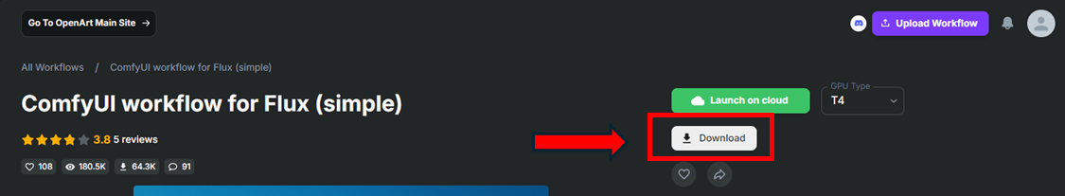

In visual programming we work with workflows to determine the flow of our program. We will drag an drop this workflow onto our ComfyUI interface. Let’s see how to do that.

**Step 6: Opening ComfyUI:**

* Within ComfyUI_windows_portable folder, if you are using windows, you will see 2 batch files run_cpu and run_nvidia_gpu. If you have an NVidia GPU, you should use that. Otherwise use CPU.
* This will open a webpage for you which is our CompyUI interface, it looks something like this:

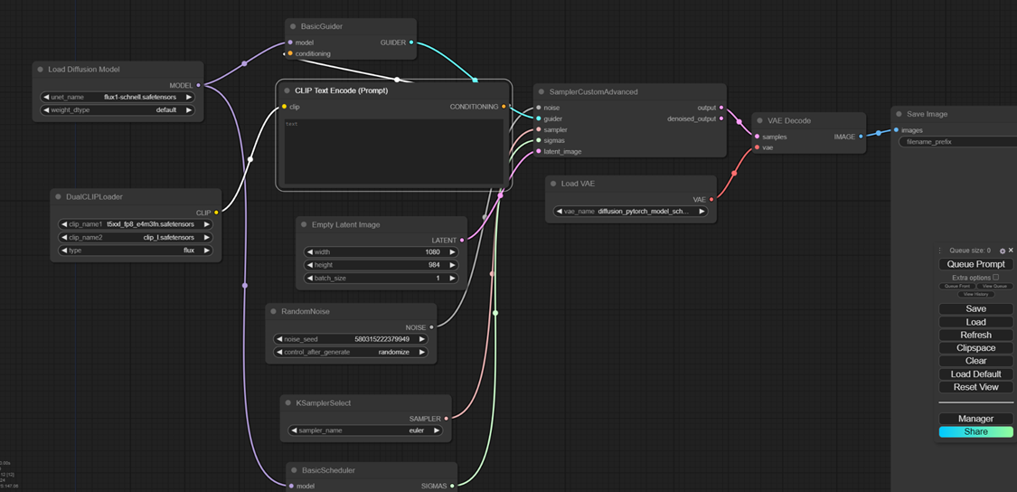

* Drag and drop the workflow you downloaded in previous section on this screen.
* Within ComfyUI manager, git Update all screen and wait for it to finish.

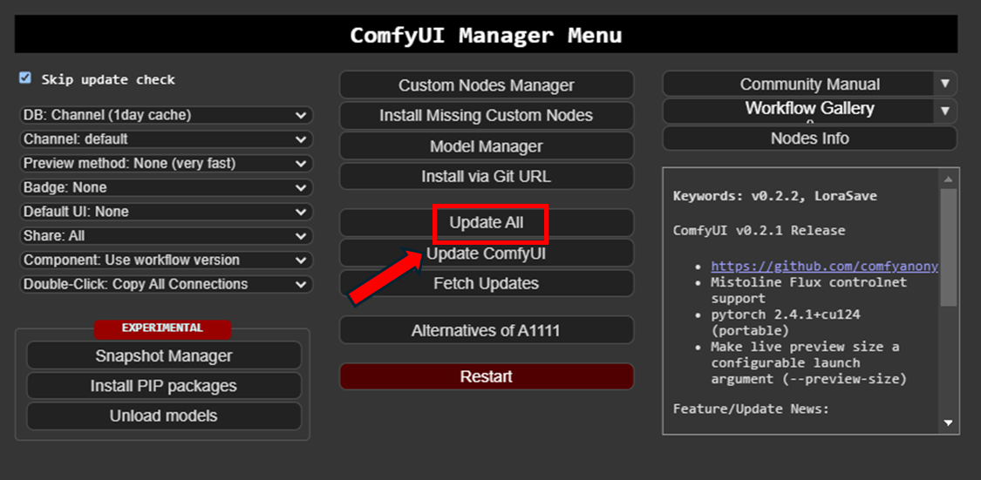

Once that is done you can start experimenting and generating beautiful images.

## With Python Notebook

To get started with FluxAI on a python notebook, we make use of environments.

### Step 1: Setting up a Python Environment

If you know how to, you can skip this step and go to step 2. Install the latest python from <https://www.python.org/downloads/>.

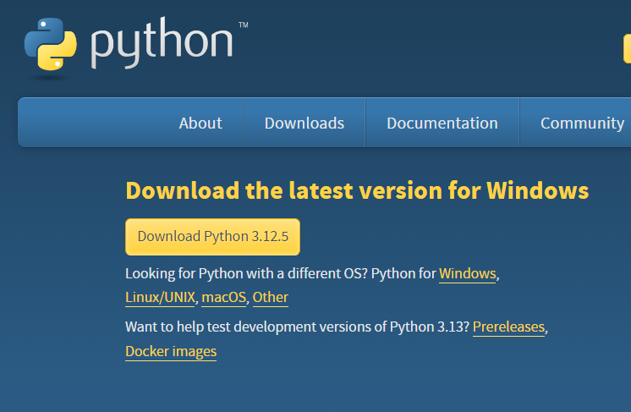

Save this file in downloads and install python where you want to create your environment. For me the path looks like this:

D:\Python Environments\Python 312

Once python is installed, Go to your Python Environments folder and open Command Prompt. Type python to see if Python has been installed, you would see something like this, this mean python is installed.

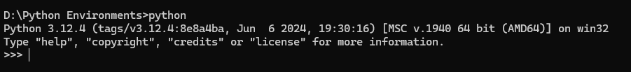

Start with typing this command:

python -m venv flux_env

This command will create a python environment called flux_env inside Python Environments. Be patient as this might take a moment.

Go inside this newly created folder “flux_env” and open Command Prompt again. Or you can direct type cd flux_env in your current cmd to change directory.

### Step 2: Activate python environment

To activate flux_env, you type this command while still inside flux_env folder:

Scripts\activate

Once you are inside your environment, you can see the environment name written in brackets like this. This denotes your environment is active.

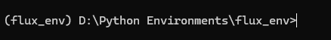

### Installation and Setup

To start, download the FLUX AI app and ComfyUI software, then follow the on-screen instructions to set them up. Once installed, open ComfyUI and start typing what you want to see in the prompt box!

### System Requirements

Any modern computer with a decent processor (like a laptop or desktop from the last few years) can handle FLUX AI. It works best with a dedicated graphics card (GPU), but it’s not mandatory.

Schnell and Dev can be run locally. I have the following software/hardware specifications:

* OS: Windows 11 Home, 64-bit operating system, x64-based processor
* Processor: AMD Ryzen 7 8845HS w/ Radeon 780M Graphics 3.80 GHz
* RAM : 16.0 GB (15.3 GB usable)
* GPU: NVIDIA GeForce RTX 4050 Laptop GPU
* VRAM: 5921 MB
* Power: upto 95 watts

With these specifications, it takes about 40 minutes for a good quality image.

You will also need 50-100GB of free space on your disk, since these models are large. Another option is to run it on collab, which results in faster rendering times.

# Chapter 3 Understanding ComfyUI Interface

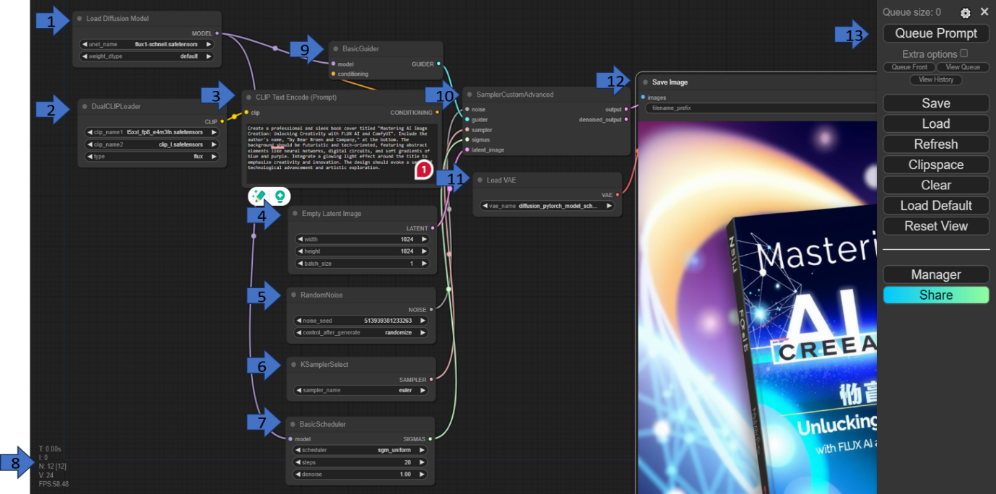

In this section, we explore a practical implementation of a generative model pipeline within **ComfyUI**, a versatile interface integrated with **Flux AI**. This setup demonstrates how different components of the diffusion process come together to generate an intricate image based on a textual description. For this example, we examine the workflow for creating a professional book cover using the Flux AI model. Each node in the interface represents a crucial stage in the image generation process, as described below.

### 1. Load Diffusion Model

The journey begins with the **Load Diffusion Model** node. Here, the core model responsible for generating images is loaded into memory. In this case, the model selected is flux1-schnell-safensor, a specialized diffusion model provided by Flux AI. The model works by progressively refining an image, starting from random noise and evolving it toward a coherent design based on the text input provided later in the pipeline.

### 2. DualCLIPLoader

The next step is the **DualCLIPLoader** node. This node loads two **CLIP** models, which play a pivotal role in understanding the connection between text and images. CLIP (Contrastive Language-Image Pretraining) models encode text descriptions and corresponding images into a shared space, allowing for effective text-based image generation. Here, two specific CLIP models are loaded:

* clip_name1 is the primary CLIP model, linked to a Flux-specific configuration.
* clip_name2 serves as a secondary model, offering an additional layer of understanding, ensuring that the image produced aligns closely with the text prompt.

### 3. CLIP Text Encode (Prompt)

The **CLIP Text Encode** node is where the magic of language begins to influence the image. The text prompt provides detailed instructions for the image that will be generated. In this example, the user describes a sleek and professional book cover with the title: *Mastering AI Image Creation: Unlocking Creativity with FLUX AI and ComfyUI*. The text specifies visual elements such as abstract shapes, digital circuits, and glowing light effects around the title, guiding the model to create a futuristic design emblematic of technological advancement and artistic exploration.

### 4. Empty Latent Image

Before the image generation begins, an initial empty canvas must be set. This is defined by the **Empty Latent Image** node, which creates a latent space for the diffusion model to work within. In this particular setup, the latent image has a resolution of 1024x1024 pixels, ensuring a high-quality, detailed output. Additionally, the batch size is set to 1, indicating that the model will generate one image per run.

### 5. RandomNoise

The diffusion process begins with noise, and this is where the **RandomNoise** node comes into play. It generates a random starting point—essentially a noisy image from which the model begins its denoising journey. The random noise ensures that each image starts uniquely, even with the same prompt. The seed value (519393813232363) allows for controlled randomness, while the setting control_after_generate: randomize ensures variability in subsequent generations after the initial image.

### 6. KSamplerSelect

The model's ability to generate an image is dependent on how well it refines the initial noise into something meaningful. The **KSamplerSelect** node specifies the sampling method that guides this process. In this case, the Euler sampler is chosen, a method known for its balance between speed and quality in image generation. This choice affects the trajectory the model takes as it navigates through the latent space, slowly shaping the image from the random noise.

### 7. BasicScheduler

The **BasicScheduler** node dictates the pacing and order in which noise is removed to form the final image. It operates based on predefined steps and denoising settings. Here, the model will perform 20 steps of denoising, gradually refining the image over each step. The denoise value is set to 1.00, indicating that the model should fully process the image, leaving no trace of the original noise. The scheduler type, sgm_uniform, determines the uniformity of the noise reduction, ensuring that the refinement happens evenly across the entire image.

### 8. ComfyUI Interface Statistics

While the model processes the image, the user interface provides real-time feedback through the **ComfyUI Interface Statistics** section. These stats give insight into the system's performance, including the time elapsed (T), number of nodes (N), number of visual elements (V), and the frame rate (FPS). These metrics are helpful for users to monitor the efficiency and speed of their workflows, especially in complex pipelines.

### 9. BasicGuider

The **BasicGuider** node integrates the previously loaded CLIP models into the image generation process. It acts as a guiding force, ensuring that the image being produced adheres to the semantic and stylistic elements described in the text prompt. In essence, this node ensures that the generated image aligns with the user’s creative vision, leveraging the CLIP text embeddings to fine-tune the model's output.

### 10. Conditioning

The **Conditioning** node ties everything together, combining the text embeddings from the CLIP models with the scheduling and sampling processes. This ensures that the specific instructions from the prompt (such as "abstract elements" and "glowing light effects") influence every stage of image generation, leading to a final output that is faithful to the original description.

### 11. SamplerCustomAdvanced

At the heart of the image generation process is the SamplerCustomAdvanced node. This node executes the core function of denoising, processing the random noise input and applying the guidance from the CLIP models. As it works, the node refines the latent space image into a coherent, visually compelling result. The node takes the noise, sampler, guide, and latent image as inputs and orchestrates the complex interactions between them to generate the final image.

### 12. Save Image

Once the image has been fully processed, it is time to save the result. The **Save Image** node captures the denoised image and saves it to the system with a specified filename prefix. This node ensures that the output is stored for future use, be it for further processing, presentation, or sharing with others.

### 13. Queue Prompt (UI Controls)

The final aspect of the interface is the **Queue Prompt** panel, where users can manage their prompt workflow. Through this panel, users have the ability to save or load prompts, refresh the interface, and clear or reset the workspace. This feature is particularly useful when working on multiple projects or testing different prompts, allowing for seamless transitions between tasks.

## Section 1: Quick Start for Image Creators

### User Interface Walkthrough

When you open ComfyUI, you’ll see a text box for typing in your image description and buttons to start the process. The generated image will appear on the right side of the screen.

### Key Features

* **Prompt Box**: Type what you want to create.
* **Generate Button**: Click it and let the AI do the magic.
* **Image Output**: Your generated image appears here.

## Section 2: In-Depth Guide for Tech Enthusiasts

### User Interface Walkthrough

The ComfyUI interface consists of multiple sections designed for ease of use:

* **Prompt Section**: Where you type the description or commands for image generation.
* **Model Controls**: Allow you to select different models, styles, and effects.
* **Settings Panel**: Contains parameters such as image resolution, sampling steps, and GPU usage.
* **Output Preview**: Displays the final image along with options for exporting it.

### Key Features and Functionality

ComfyUI includes advanced tools for:

* **Model Integration**: Allows loading of multiple pre-trained models for varied outputs.
* **Real-Time Preview**: Adjust parameters and see the results before finalizing.
* **Custom Templates**: Create templates for repeated tasks and workflows.

# Chapter 4 Basics of Image Generation with FLUX AI

## Section 1: Quick Start for Image Creators

### Simple Image Generation

1. Open ComfyUI.
2. Type something simple like “A dog playing in a park” in the prompt box.
3. Click **Generate**.
4. In a few seconds, you’ll see your image!

## Section 2: In-Depth Guide for Tech Enthusiasts

### How FLUX AI Uses Generative Models

FLUX AI is built on a combination of generative models that include neural networks trained to recognize patterns in text and images. Using GANs and VAEs, FLUX AI can create visually coherent outputs based on prompts, learning from millions of images across different styles and genres.

### Simple Image Generation Techniques

To create a basic image, follow these steps:

1. Load FLUX AI in ComfyUI.
2. Input a detailed prompt like “A cyberpunk city at night, with neon lights and flying cars.”
3. Set parameters such as image resolution and style (e.g., photorealistic, painterly).
4. Click **Generate** and analyze the generated image for further adjustments.

Examples

In this section we will explore some example prompts with the resulting outputs.

**Prompt 1:**

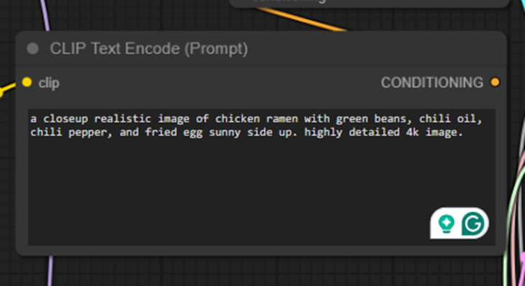

**Output 1:**

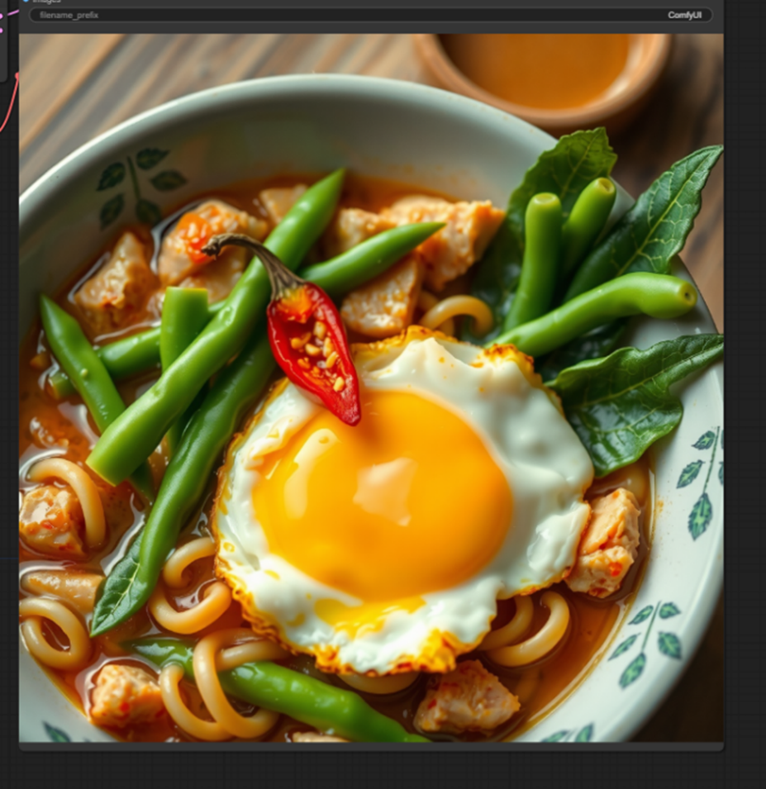

Same prompt different settings resulted in following images:

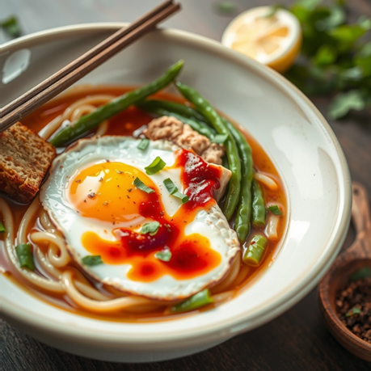



**Example 2:**

**Prompt 2:**

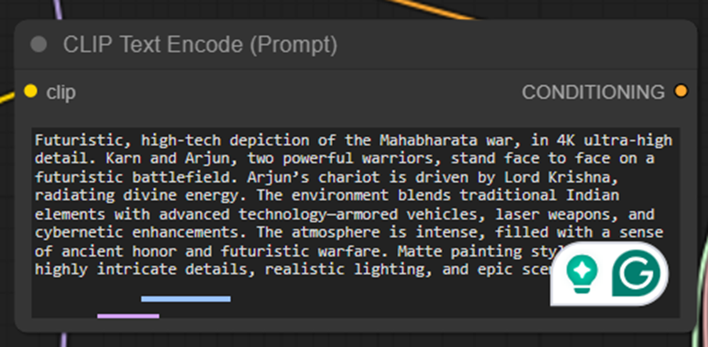

**Output 2:**

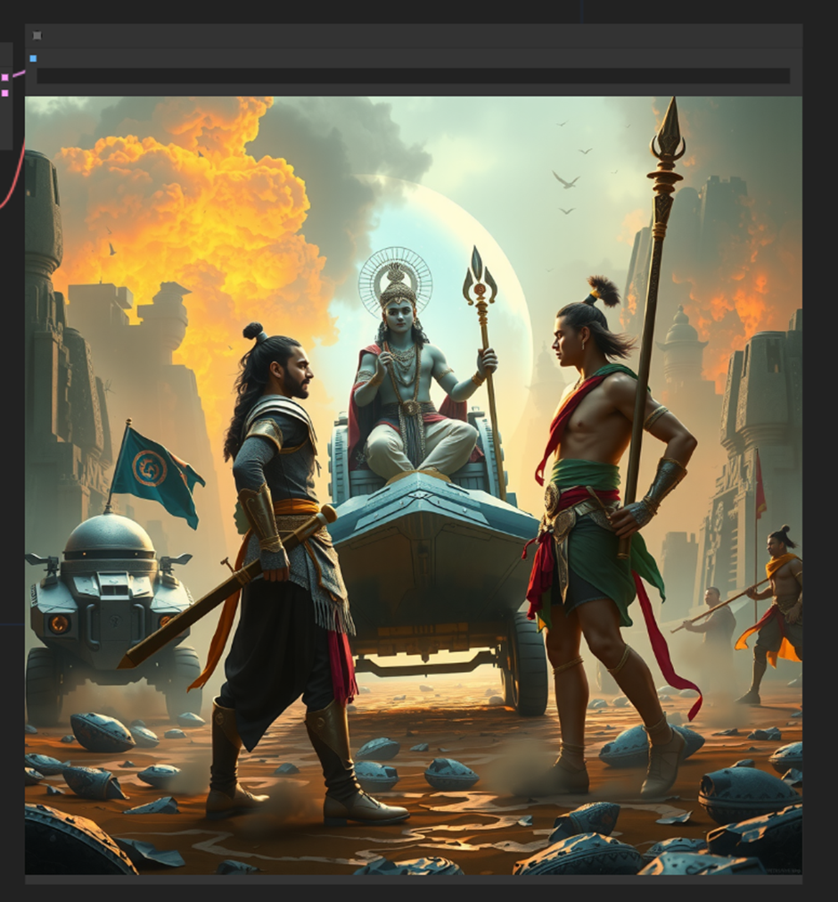

**Example 3:**

**Prompt 3:**

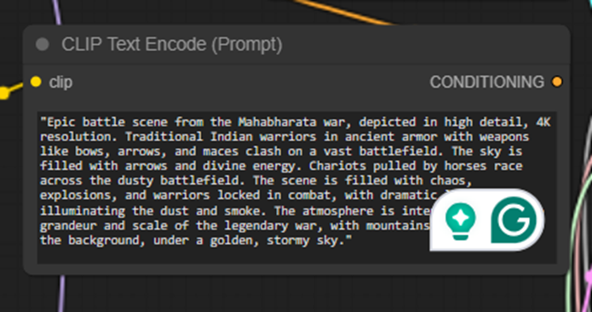

**Output 3:**

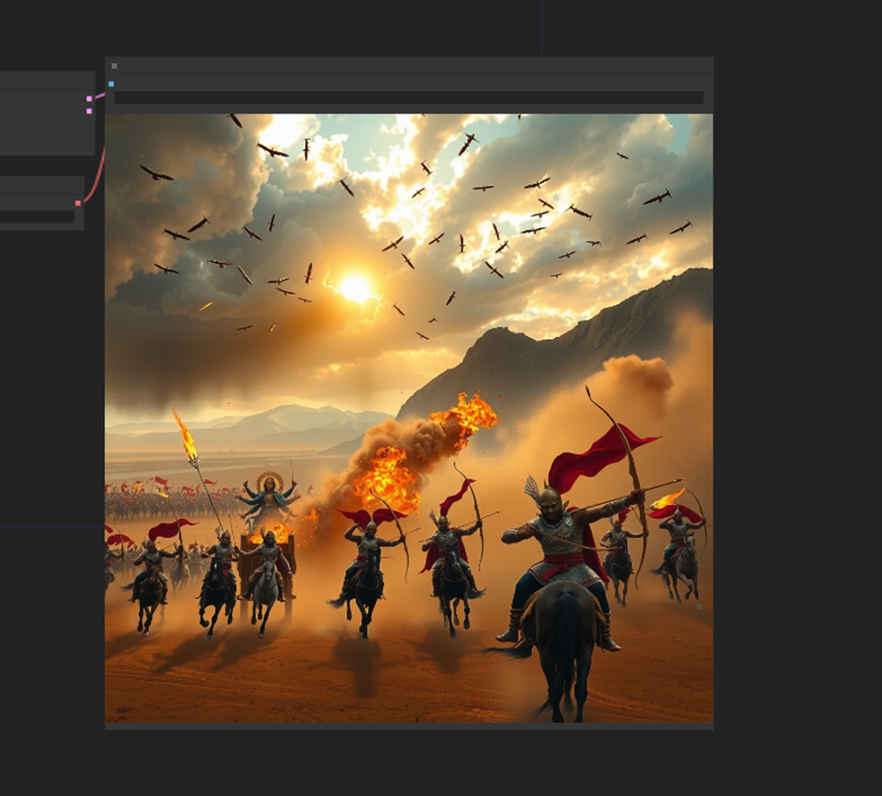

For the same prompt but different settings:

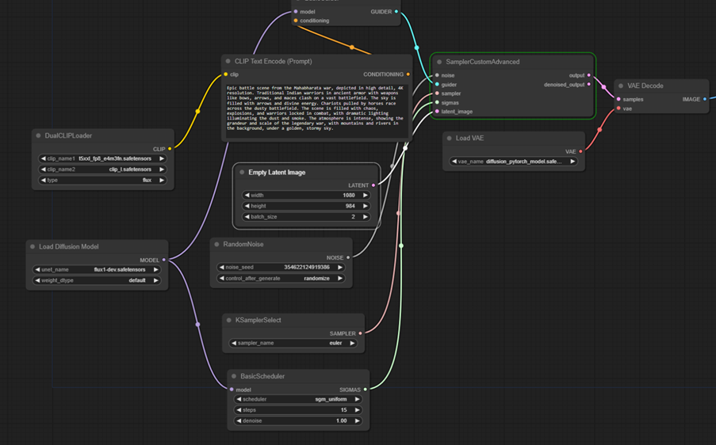

Outputs:





# Chapter 5 Advanced Image Generation Techniques

## Section 1: Quick Start for Image Creators

### Experimenting with Prompts

Try experimenting with different prompts to see what FLUX AI can generate. For example:

* “A magical forest with glowing trees”
* “A space station orbiting a distant planet”

Simply type your prompt and click **Generate**.

## Section 2: In-Depth Guide for Tech Enthusiasts

### Detailed Prompts and Instructions

FLUX AI responds well to detailed descriptions. For example, instead of “a sunset,” you can specify:

* **Prompt**: “A golden sunset over a calm ocean, with a sailboat in the distance and seagulls flying overhead.”
* **Additional Parameters**: Use sliders to adjust lighting, colors, or focus on certain elements for a more personalized output.

### Fine-Tuning Model Outputs

Advanced users can tweak parameters such as:

* **Sampling steps**: Controls the amount of noise added during generation for different textures.
* **Control over multiple layers**: Modify individual components of the image for complex compositions.

# Chapter 6 Customizing Images in ComfyUI

## Section 1: Quick Start for Image Creators

### Applying Effects and Styles

Want to give your image a unique style? ComfyUI allows you to apply filters like sepia or black and white. Just choose a filter before generating the image.

## Section 2: In-Depth Guide for Tech Enthusiasts

### Layering and Advanced Customization

With ComfyUI’s advanced layering features, you can:

* **Overlay effects**: Apply artistic or photo filters layer by layer.
* **Combine elements**: Create complex scenes by merging different images or adjusting opacity and contrast for each layer.

# Chapter 7 Optimizing AI-Generated Images

## Section 1: Quick Start for Image Creators

### Improving Image Quality

If the image quality isn’t what you expected, simply increase the resolution or try different prompt phrasing for better results.

## Section 2: In-Depth Guide for Tech Enthusiasts

### Removing Artifacts and Refining Outputs

ComfyUI has several post-processing tools that allow you to:

* **Denoise outputs** to reduce unwanted pixelation or blurring.
* **Use super-resolution** tools to enhance fine details and edges, perfect for printing or high-quality visuals.

# Chapter 8 Use Cases for FLUX AI Image Generation

## Section 1: Quick Start for Image Creators

### Real-Life Applications

You can use FLUX AI for:

* **Social Media Posts**: Generate eye-catching visuals for Instagram or Twitter.
* **Personal Art Projects**: Create unique pieces for your home or to share with friends.

## Section 2: In-Depth Guide for Tech Enthusiasts

### Professional Applications and Use Cases

In professional settings, FLUX AI is valuable for:

* **Advertising**: Generating creative marketing materials and visual ads.
* **Gaming and Movies**: Creating concept art and visual storyboards.
* **Web Development**: Generating visuals for websites, especially in creative industries.